RESOLUTION NO.__________

RE: CERTIFICATE OF APPROPRIATENESS UNDER THE
PROVISIONS OF THE ACT OF THE PENNSYLVANIA
LEGISLATURE 1961, JUNE 13, P.L. 282 (53
SECTION 8004) AND BETHLEHEM ORDINANCE NO.
3952 AS AMENDED.

WHEREAS, it is proposed to replace the damaged store front at 25 E Third Street.

NOW, THEREFORE, BE IT RESOLVED by the Council of the City of Bethlehem that a Certificate of Appropriateness is hereby granted for the work.

Sponsored by: (s)

(s)

ADOPTED BY COUNCIL THIS DAY OF

(s)
President of Council

ATTEST:

(s)
City Clerk

HISTORIC CONSERVATION COMMISSION

CASE # 598– It is proposed to replace the damaged store front at 25 E Third Street
OWNER/APPLICANT: Ravi and Tara Nagabhyru

The Commission upon motion by Ms. Starbuck seconded by Mr. Hudak adopted the proposal that City Council issue a Certificate of Appropriateness for the proposed work described herein:
- The proposal to replace the damaged store front at 25 E Third Street was represented by Ravi Nagabhyru.
- Work will include new tile on the knee wall, areas around and above the entrance door, new aluminum storefront framing and glazing, and new awnings.
- The tile will be 12”x 24” in size and be set in a running bond. The tile spec is Dal Tile Fabrique Colorbody porcelain in the Gris Linen color.
- The area above the existing clear storefront windows will be changed to be spandrel glass with clear anodized framing. The glass will have one etched layer over a black layer of glass.
- The proposed awnings would be fabricated of Sunbrella fabric and have open ends. The awning would not be located above the door to create a taller and more obvious entry. The awning color will be Sunflower.

- The motion to approve the proposal was unanimously approved.

CU: cu
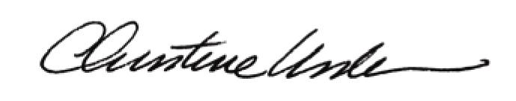

By:

Date of Meeting: September 19, 2016 Title: Historic Officer

